# Republic of the Philippines

**DEPARTMENT OF SCIENCE AND TECHNOLOGY**

**Provincial Science and Technology Center – Pangasinan Satellite Office**

PSU- Urdaneta Campus, Urdaneta City, Pangasinan

# NARRATIVE ACCOMPLISHMENT REPORT

**January**

1. **PROMOTE ADOPTION/ UTILIZATION OF TECHNOLOGIES FROM PUBLICLY FUNDED R&D**

|  |  |  |  |
| --- | --- | --- | --- |
| **Technology/ies**  **Promoted** | **Promoted through** | **Date/Venue** | **REMARKS** |
| STARBOOKS | Facebook | Shared on Jan 5 |  |
| Household Tumbling Composter | Facebook | Shared on Jan 7 |  |
| Organic Lettuce Production | Facebook | Shared on Jan 29 |  |
| Production of organic fertilizer | Facebook | Shared on Jan 29 |  |
| Integrated Ornamental Horticulture R&D Program: Recommended Practices in the Production of Palms | Facebook | Shared on Jan 29 |  |
| Vigormin | Face to face discussion | January 22/ PSTC | Tayug Family Hospital |
| Biotek-M | Face to face discussion | Jan 19/ San Nicolas | Cong. Agabas |

|  |  |  |  |
| --- | --- | --- | --- |
| **Technology/ies**  **Adopted/Utilized** | **Name of Adoptor/s** | **Date Adopted/Utilized** | **REMARKS** |
|  |  |  |  |
|  |  |  |  |
|  |  |  |  |

1. **PROVIDE SUPPORT MECHANISMS FOR STARTUPS, MSMES, INDUSTRIES AND OTHERS IN THE REGION.**

***2.1 NUMBER OF S&T INTERVENTIONS***

* **Technology Transfer and Management (Innovation Enabling Fund)**

* *system improvement/equipment acquisition: regardless of the number of equipment =*

*1 intervention (technology upgrading)*

*\* 4 diff types of eqpt, 1 firm = 4 interventions*

*\* manpower development: 1 type of training = 1 intervention*

*\* process improvement: plant layout improvement = 1 intervention*

*\* 1TNA report/project = 1 intervention*

*\* product improvement/development ( including P/L, testing): 1 product, 2 test = 2 interventions*

|  |  |  |
| --- | --- | --- |
| **Name of Firm** | **Interventions Provided** | **REMARKS** |
| Rod’s Jellycacies | TNA | Scheduled on the SETUP TNA Validation of Regional Office |
| KWJ Enterprises |
| Pon’s Mushroom |
|  |

* ***Technology Trainings/Seminars:*** *(example: 1 training, 2 technologies = 2 interventions)*
* ***Technical Consultancy Services***

*Any scientific/technical/expert advise, recommendations rendered in any manner either directly or indirectly to customers: FS, CP, etc. 4 recommendations, 1 customer = 4 interventions*

*walk-in: 1 customer = 1 intervention*

|  |  |  |  |
| --- | --- | --- | --- |
| **Name of customer** | **TACS provided** | **Recommendations** | **REMARKS** |
|  |  |  |  |

* ***Packaging & Labeling***
* ***S&T INFORMATION and REFERRAL***

|  |  |  |  |  |
| --- | --- | --- | --- | --- |
| * + - * 1. **Name of Client/Firm** | * + - * 1. **Address** | * + - * 1. **Inquiry/ies** | * + - * 1. **Action Taken** | * + - * 1. **Remarks** |
| Joycelyn Orpiano | * + - * 1. Urdaneta | * + - * 1. PSHS NCE application | Referred to PSHS admin | Walk-in |
| Leonora Solis | * + - * 1. Urdaneta | * + - * 1. PSHS NCE application | Referred to PSHS admin | Walk-in |
| Dante Bersamin | * + - * 1. Urdaneta | * + - * 1. PSHS NCE application | Referred to PSHS admin | Walk-in |
| Angeles D. Gacud | * + - * 1. Urdaneta | * + - * 1. PSHS NCE application | Referred to PSHS admin | Walk-in |
| Zenaida B. Bautista | * + - * 1. Urdaneta | * + - * 1. PSHS NCE application | Referred to PSHS admin | Walk-in |
| Jonalyn B. Poserio | * + - * 1. Urdaneta | * + - * 1. PSHS NCE application | Referred to PSHS admin | Walk-in |
| Marian Tabangcura | * + - * 1. Asingan | * + - * 1. Follow up scholarship allowance | Checked on Scholarship Unit’s posting of allowance | Walk-in |
| Paul Tabangcura | * + - * 1. Asingan | * + - * 1. Follow up scholarship allowance | Checked on Scholarship Unit’s posting of allowance | Walk-in |
| Anely Marie Ramos | * + - * 1. San Manuel | * + - * 1. Asking for DOST endorsement letter to UST Scolarship- Legal management enrolee | Informed that DOST does not endorse for such matter | Walk-in |
| Marife Manalastas/ Panelco III | * + - * 1. Urdaneta | * + - * 1. Livelihood Training for their clients | Requested to send formal letter | Walk-in |
| Lolita Cariño | * + - * 1. Mangaldan | * + - * 1. SETUP | Scheduled for TNA visit | Walk-in |
| Alpha R. Almonte | * + - * 1. Dagupan | * + - * 1. WACS plan and handouts during the WACS training last Sept. 2-3, 2020 | Forwarded the documents | FB messenger |
| Tayug Family Hospital | * + - * 1. Tayug | * + - * 1. Biogas Composter Technology | Endorsed to ITDI | Walk-in |

**2.2 NO. OF START-UPS/ENTERPRISES/SPIN-OFFS ASSISTED/CREATED (COMMUNITY-BASED)**

|  |  |  |
| --- | --- | --- |
| **Name of Firm** | **Interventions Provided** | **REMARKS** |
|  |  |  |
|  |  |  |
|  |  |  |

***2.3 NUMBER OF JOBS GENERATED***

|  |  |  |  |
| --- | --- | --- | --- |
| **Name of Firm** | **No. of Jobs Generated** | | **Total** |
| **Male** | **Female** |  |
| * + - * 1. DC Danzcut Stickers | * + - * 1. 3         2. (Arturo De Guzman, Arnel De Guzman, Romulo Cachio) | 0 | 3 |
| * + - * 1. R.J. Body Build & Welding Shop | * + - * 1. 2   (Tomas E. Comon,  Keysee Rhey A. Jutie) | 0 | 2 |
| **TOTAL** | **5** | **0** | **5** |

***2.4 PERCENTAGE INCREASE IN PRODUCTIVITY – 11.07%***

***2.5 GROSS SALES GENERATED: 9,167,559.00***

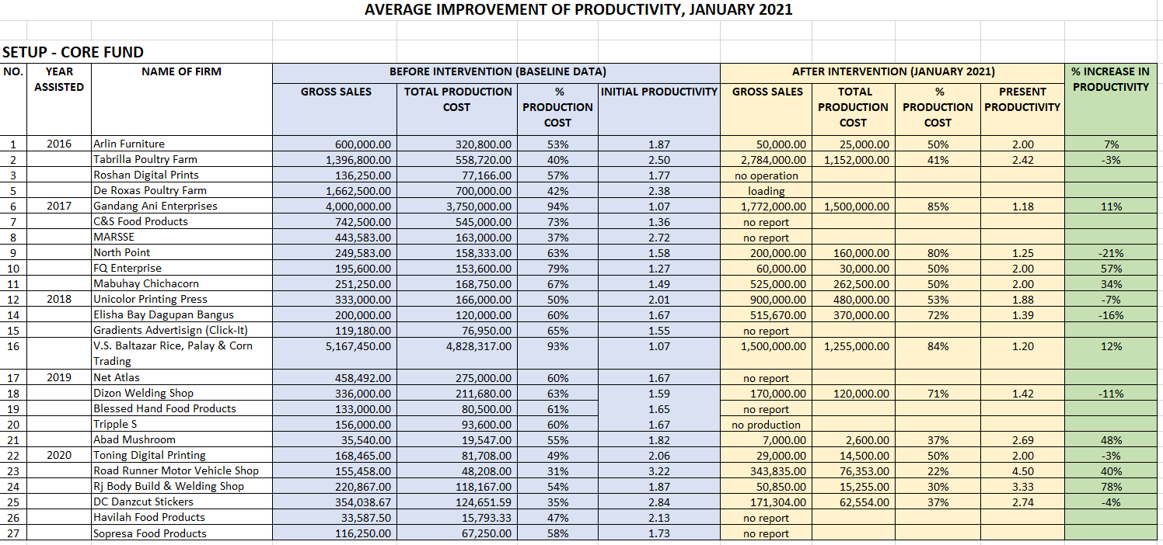

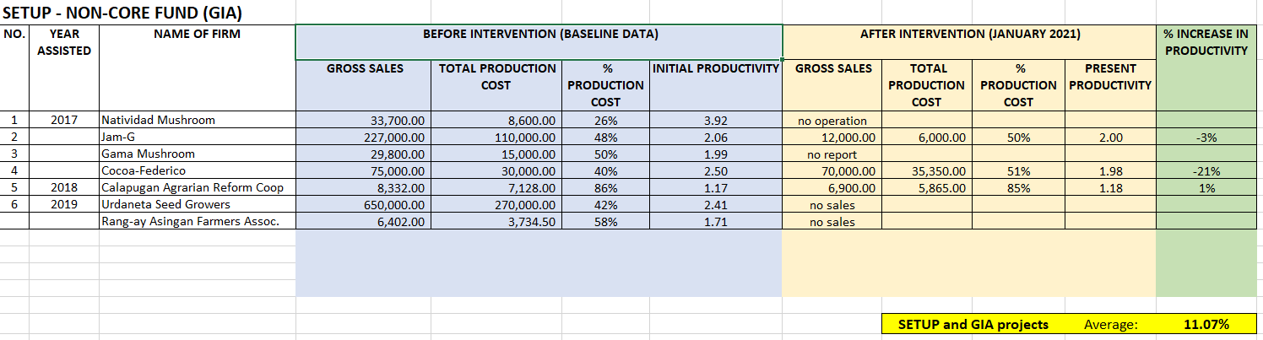

1. **STRENGTHEN REGIONAL STANDARDS AND TESTING LABORATORY SERVICES**

* ***Testing/calibration (paying)***

|  |  |  |  |
| --- | --- | --- | --- |
| **Name of customer** | **No. of units calibrated** | **Income Generated (Php)** | **REMARKS** |
| LGU Urdaneta | 64 units | 19,660.00 |  |

1. **STRENGTHEN PARTNERSHIP WITH OTHER INSTITUTIONS**
   * + - 1. **Networks/linkages established/maintained**

|  |  |
| --- | --- |
| **Networks/Linkages** | **Activities Undertaken** |
| LGU Urdaneta | Calibration Services |
| Office of the Representative 6th District Pangasinan | Courtesy Call of PPAs Discussion Jan19 |
| Office of the Representative 4th District Pangasinan | Courtesy Call of PPAs Discussion Jan30 |

1. **HUMAN RESOURCE DEVELOPMENT**

|  |  |  |
| --- | --- | --- |
| **Title of Training/Seminar**  **Attended (Webinar)** | **Name of Staff** | **Date** |
|  |  |  |
|  |  |  |

1. **SUPPORT FUNCTIONS**
2. ***REGIONAL ACTIVITIES***
3. ***PROVINCIAL ACTIVITIES***

* Awarding of Check to Bileg ti Panagmaymaysa on Jan. 14

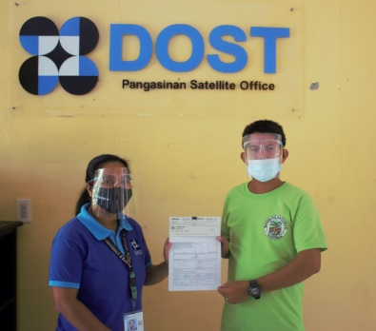

* Calibration Services in San Vicente, Urdaneta City on Jan. 21-22

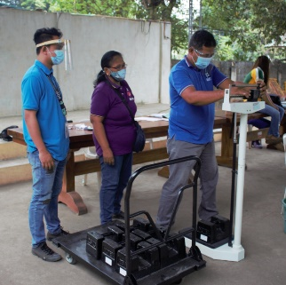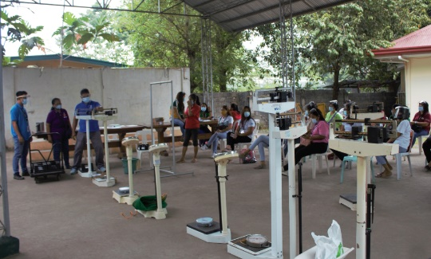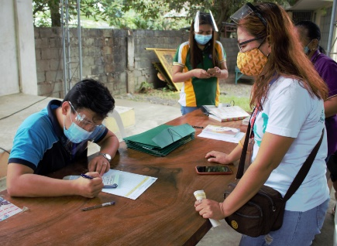

* AMERIAL Site Visit to SETUP cooperators with MIRDC team on Jan. 25-26

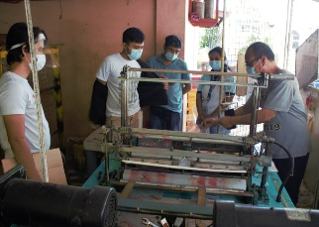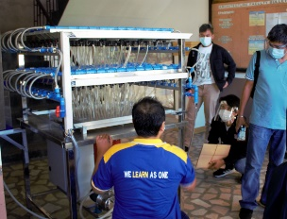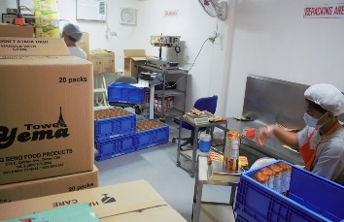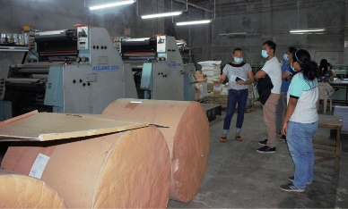

* Calibration Services in Alaminos City on Jan. 27-28 (GTD)
* Meeting with Congressman Agabas
* Meeting with Congressman DeVenecia
* **REFUND COLLECTION**

*(Coordinated and collected refund with respective on-going project beneficiaries)*

|  |  |  |  |  |
| --- | --- | --- | --- | --- |
| ***MONTHLY REFUND COLLECTED*** | | | | |
| **Month** | **2018** | **2019** | **2020** | **2021** |
| January | 894,918.66 | 1,116,052.66 | 894,054.21 | 494,369.33 |
| February | 722,666.31 | 516,429.09 | 82,436.00 |  |
| March | 417,195.33 | 668,415.21 | 526,940.33 |  |
| April | 829,841.32 | 647,066.09 | No deposit |  |
| May | 478,598.33 | 924,341.33 | 68,928.88 |  |
| June | 490,408.33 | 444,367.21 | 4,600.00 |  |
| July | 805,532.32 | 746,846.21 | 77,305.00 |  |
| August | 602,192.33 | 666,193.58 | 590,958.61 |  |
| September | 325,930.21 | 344,016.33 | 575,449.33 |  |
| October | 775,283.32 | 483,013.09 | 512,248.33 |  |
| November | 615,042.21 | 658,249.33 | 354,707.33 |  |
| December | 754,908.92 | 648,310.33 | 265,000.19 |  |
|  | **7,712,517.59** | **7,863,300.46** | **3,952,628.21** | **494,369.33** |

* **SETUP/Community-Based**
* TNA Visit to Rod’s Jellycacies, KWJ Enterprises and Pons Mushroom

on Jan. 13

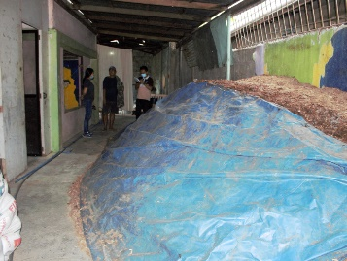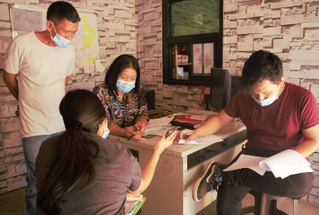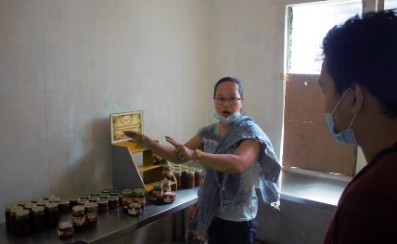

* TNA Validation on Jan. 28-29 with KWJ Enterprises, Jojo Auto Shop, Emoh-Ruo Prints, Hi-Chi Farm, Doris Furniture Shop, Jameel Mushroom and Pon’s Mushroom Farm
* **STARBOOKS**
* No deployment done
* **SCHOLARSHIP**

|  |  |  |
| --- | --- | --- |
| **Scholarship Promoted** | **Date** | **REMARKS** |
| Requirements for Admission, Criteria and Evaluation (RACE) for incoming Grade 7 students in year 2021-2022 for the  Philippine Science High School (PSHS) is extended until January 15. | Jan 6 | Shared on FB page |

* **S&T PROMOTIONAL ACTIVITIES CONDUCTED**
* Facebook posts



**JENNIFER C. FERNANDEZ**

OIC/SRS II